Tölt Club Boldness Challenge
October 2019
It’s Halloween at the end of the month so we have a spook-tastic course for you this time!
- The Button you should really never ever press… Cut out a small circle from a piece of carpet/rubber doormat. The circle should be 12” (30cm) in diameter. Halt your horse with his front left foot on the ‘button’. Make sure we can see it in the video.
- The Spiral of DOOM. Make a pole cartwheel by arranging four poles like the spokes of a wheel and raising the inner ends on a trye or bucket. Walk clockwise around the wheel, stepping over the poles without touching them. The closer your horse can go to the middle of the wheel the better.
- The Pit of Despair Lay a large tarp on the ground and place some planks across it to form a bridge. If you can’t find any planks you could use a narrow carpet or strips of rubber matting. The ‘bridge’ should be 2’/60cm wide. Walk over the bridge with your horse – all six feet must be on the bridge so you don’t fall ino the pit, never to be seen again.
- Monster Alley Set up a scary corridor of flags, monsters, pumpkins, spiders, etc., and walk through it with your horse. Aim for the corridor to be about 2m wide and at least 3m long. If 2m is too narrow for your horse to feel comfortable, try putting scary things only on one side.
- Magic Portal Make a portal to walk through, with something on the floor, solid sides, and a something to walk under. Use your imagination!
- Haunted Forest Make a haunted forest by attaching flappy white plastic bags to cones or electric fence posts. Set up five ‘ghosts’ in a line, about 3m apart, and weave between them with your horse.
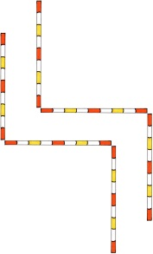
- Poisoned Path Set up a zigzag corridor of poles (with a 90 degree right turn then a 90 degree left turn) so you can use it to escape the scary Halloween world. Walk through it with your horse without stopping, touching, or stepping outside the poles.

